Maria Mitchell:
First Woman Astronomer in America
By Jane Opalko
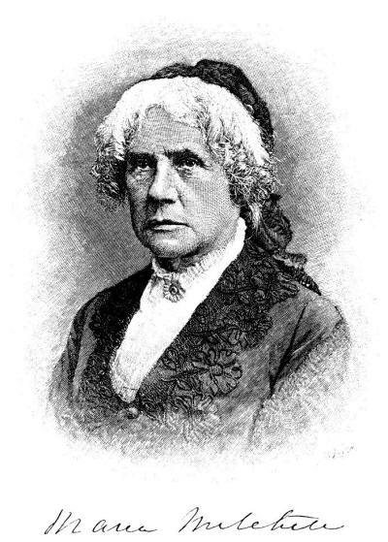
Cold wind ships across Nantucket’s dunes and blows around a railed rooftop where a man and girl study a star chart. Maria Mitchell tightens her cloak about her before turning to look through her father’s small brass telescope again. Her warm bed waits below, where her brothers and sisters are already asleep, but Maria can’t bear to go downstairs yet; the wind has just blown away winter clouds, and stars glitter over the Atlantic Ocean.

The year was 1830, and Nantucket, a tiny island off the coast of Massachusetts, was the center of the world whaling trade. Sea captains in search of precious whale oil sailed their ships from Nantucket all the way to the Pacific Ocean and back, steering only by the stars. Twelve-year-old Maria (pronounced Ma-rye-a) Mitchell scarcely suspected that someday the stars would also lead her far beyond Nantucket. Maria’s father, William Mitchell, was an accomplished amateur astronomer as well as a teacher, farmer, and fixer of chronometers (clocks carried aboard sailing ships). He soon noticed that Maria, the third of his nine children, shared his passion for astronomy. Her sharp eyes easily found the faintest stars, and she questioned every fascinating object she saw through the telescope.

A Persistent Scholar

When nights were too cloudy for observing, Maria studied astronomy and learned
mathematics in a closet under a staircase. She wasn’t hiding, the closet was simply the quietest place to study in her large, family-filled home. Maria was no math whiz, but she was persistent; she puzzled over equations for calculating star positions and planetary orbit for hours until she understood them completely.
Although there were no women astronomers in America, Maria was never
discouraged from studying. Nantucket women had always been different; they handled the men’s work when their husbands and sons were at sea, and women participated equally with men in the Quaker religion, which many Nantucket families practiced. Ships brought books to Nantucket from around the world, and more than 3,000 filled the Atheneum, a library where Maria began to work when she was 19. Maria attended schools on Nantucket until she was 16, then she taught school for two years. As always, her education continued; as she sat behind her librarian’s desk, Maria’s mind soared as she read books of all kinds, but especially books on astronomy and mathematics.

Maria Mitchell's Observatory at
Lynn, Massachusetts

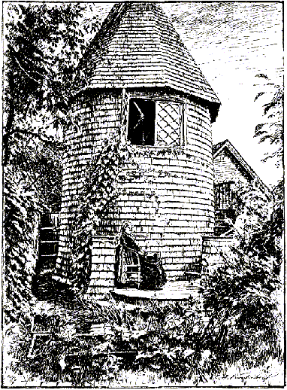
Reading in the Atheneum by day and observing at night, Maria’s routine rarely changed for a decade. Then, on the first night of October 1847, she spotted a fuzzy patch of light through her father’s telescope. She wondered if it was a comet, or if she’s forgotten about a faint nebula in the region. Her heart raced as she carefully checked her star chart, which showed that the region was usually dark!

Calculating a Comet’s Position

Anyone can become famous for discovering a comet, but Maria accomplished more than this: Night after night, she carefully measured the new comet’s position, then she painstakingly calculated its orbit. Maria’s calculations distinguished her as a serious astronomer, not just a casual stargazer; consequently, she was elected as the first woman member of both the American Academy of Arts and Sciences and the Association for the Advancement of Science. During her lifetime, Maria received several honorary college degrees, two medals, and a beautiful new telescope in recognition of her accomplishments as an astronomer. Today, a crater on the moon is named Mitchell in her honor.
Ten years after discovering her comet, Maria traveled by train and stagecoach
through the American South, then on to Europe by steamship. As a famous
astronomer, Maria was welcomed everywhere and introduced to many scientists, but the only woman scientist she met was the English mathematician Mary Somerville. After two years of travel, Maria returned to Nantucket hoping to help more women become scientists.

Changing Attitudes About Women

American was soon embroiled in the Civil War, which ended slavery and also
helped change attitudes about women. When the war ended in 1865, a wealthy
businessman named Matthew Vassar opened a college for women in Poughkeepsie, New York. He asked Maria to teach astronomy and direct the college observatory; she eagerly accepted this opportunity to give young women a formal education in astronomy. Maria taught astronomy at Vassar College, but she encouraged her students to become whatever they wanted. Some of them did become astronomers, and a few became scientists in other fields. Maria’s influence extended beyond the college walls, as she encouraged women everywhere to educate themselves. “I believe in women even more than I believe in astronomy,” she said. In more ways than one, Maria Mitchell helped many women reach for the stars.

May 1998 ©Washington State Commission on Student Learning
Women Astronomers - Reading Book

Spiraling Among the Stars:
an Interview with Vera Rubin
By Barbara Sprungman and Leonard David

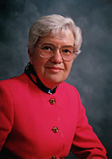
Vera Rubin has come face to face with the universe. Her work has led to our understanding that much of what we observe- stars, gaseous nebulae, and many other mysterious celestial objects beyond the solar system- is but a small percentage of the overall mass in the universe. The larger percentage is what is termed “dark matter.” Shedding light on dark matter is just one of Dr. Rubin’s many contributions to astronomy. Her thoughts and research findings have been published in many astronomical journals around the world. Dr. Rubin currently holds a position as astronomer in the Department of Terrestrial Magnetism at the Carnegie Institute of Washington in Washington, D.C. Born in 1928, she has held a number of professional research posts at the Naval Research Laboratory, the Vatican Observatory Summer School, and the Institute for Advanced Study. She has served on astronomy panels and councils and has lectured around the world. As a recent indication of her continuing contributions, Vera Rubin was awarded the 1993 National Medal of Science, presented to her in a White House ceremony by President Bill Clinton. We were pleased to talk with Vera Rubin recently and to learn about her personal relationship with the universe that surrounds us all for this issue of ODYSSEY.

How did you first become interested in astronomy?
As a child, I had a bed under a window that faced north. About every 10 minutes you could see that the position of the stars changed as the Earth rotated. I was about 10 or 12, and I found watching the sky more interesting than sleeping. I just decided to become an astronomer. My parents were totally supportive of whatever I wanted to do.

What was it like in the earlier years when you were first pursuing your career as an astronomer?
Well, the world was different in some measure. Science is a very male-dominated world. The historical condition is that universities founded hundreds of years ago were male domains. They intentionally did not include women. American women first got their own academies around 1820, and they did it with the argument that education would make them better mothers. I mean, they didn’t believe it and that was not why they were doing it, but public education for women did not exist. So historically, academia has been male-dominated, and science is still male dominated. For example, until 10 years ago women were about 2 percent of the physicists. It means that you are such an exception that you are not part of the main establishment. The situation is changing in the sense that there are now larger numbers of women studying science, and industry is hiring them.

What has influenced the changes?
Laws. It is illegal to discriminate now on the basis of sex. I would encourage any
young woman who thinks she wants to be a scientist or an astronomer to do it. It is enormous fun. It’s enormously rewarding, but there are enormous battles to fight. When I was an undergraduate at Vassar, I wrote Princeton University a postcard requesting a catalog of the graduate school. I got back a letter from the dean of the graduate school saying that, inasmuch as they did not accept women, they would not send me a catalog. Princeton began to accept women in its astronomy and math graduate school in the 1970s. I was the first woman permitted to observe at Palomar Observatory in California in 1965. That may seem like a long time ago to young people, but it wasn’t 100 years ago.
Women had been excluded on the grounds that the building had only one toilet. The living quarters were called “the monastery,” so [the “males only” philosophy] was built into the culture of the science.

It seems as though every day in the paper we read about new discoveries in astronomy. Are more important discoveries being made?
There have always been that many discoveries, but now there are more science
writers. Every astronomer is making discoveries, but they were never reported to the press unless they were so phenomenal that they had to be reported.

With all these new discoveries, our ODYSSEY readers might think there isn’t anything left to discover.
I would say just the opposite. Most of the discoveries are yet to be made. We know very, very little about the universe. There are major, fundamental things that we have not yet discovered. No one is creative enough to imagine these things until they are observed. That happens every day in astronomy. We are probably out of kindergarten as far as astronomy goes, but we are not into junior high yet.

What does it feel like to make a new discovery in astronomy?
Occasionally there is a discovery that is somewhat instantaneous. Last year I
discovered a very strange galaxy, a disk galaxy, in which half the stars go one way and half the stars go the other way. It had been assumed that nothing like that could ever exist. After two years of hard work trying to understand and continuing to wonder about it ... suddenly one day I did one thing in an instant that solved the problem. That’s a wonderful feeling-to believe that you learned something that no one has ever known before.

How has being a professional astronomer affected your family life over the years- for instance, when you had to leave to observe?
I didn’t go observing more than once or twice a year. My husband and four children often came with me or picked me up. It was just part of the family life, and, I think, a very enjoyable part. My children grew up in a world where scientists were always coming into the house. Interesting subjects were always being discussed over dinner. I think they thought their parents were having an awful lot of fun. It’s a very satisfying, very exciting life.

May 1998 ©Washington State Commission on Student Learning
Women Astronomers - Reading Book

